**Revolutionizing Retail Dynamics: AI-Powered Market Intelligence**

# Abstract:

The developing market district scene, driven by digitization, demands a wide comprehension of arising models and weights. This speculative presents a course of action of motorized hypothesis driven farsighted evaluation inside the market space, covering establishment, issue explanation, frameworks, data use, and results. Of late, the blend of man-made scholarly capacity (motorized thinking) and sagacious assessment has been instrumental in reshaping market parts. Unintentionally, productive utilization of these advances expects to pay special attention to difficulties, for example, moral evaluation in data-driven strong cycles. The appraisal looks at imaginative methods and arising models worked with by man-made academic capacity, especially focusing in on client responsibility and sales evaluation. Using key thought of imitated data and knowing evaluation strategies, the review needs to translate client leads, demand models, and market plans. Convincingly, a mix of quantitative and critical methods is utilized, underlining moral practices in data assortment and evaluation. Certifiable setting-focused appraisals show the central advantages of electronic thinking drew in techniques, recalling working for possible ease and overhauled client upkeep. This thought fills in as a resource for industry-arranged specialists, scientists, and policymakers taking a gander at the developing scene of man-made data driven market data. It needs to change market experiences through man-made data controlled reasonable assessment while watching out for difficulties, for example, data morals and security concerns. Expected results coordinate the improvement of creative man-made data partook in a farsighted evaluation structure phenomenally made for the market business, working with data-driven free course and fundamental status. Clear advantages for useful execution coordinate transcendent execution assessments, high level evaluation contraptions, market datasets, and pleasing entrances.

**Acknowledgment**

We imparted our huge appreciation to God for give us direction, strength, and intelligence through the difficulties we looked during the satisfaction of this endeavor. Reliably, we have been regarded with your brilliant heading, which has empowered us to vanquish avoidance and appear at this immense achievement in our instructive cycle. Without your resolute help, we couldn't have ever made the decision to research the intricacies of our authentication program. We ought to bestow our overwhelming appreciation to our endeavor chief, whose basic direction and steadfast help have been instrumental in the productive satisfaction of this endeavor. His skill, support, and commitment played a colossal impact in directing us through every time of the endeavor, from starting as far as possible. We are genuinely enthusiastic about his mentor boat and association, which have assisted us with accomplishing our objectives and targets.Moreover, we are profoundly appreciative to our steady guardians and companions for their genuine love, consolation, and understanding all through this excursion. Their steadfast confidence in our capacities and their ceaseless help have been a consistent wellspring of solidarity and inspiration. We are profoundly appreciative of their penances, support, and useful tidbits, which have roused us to endure and take a stab at greatness. We might want to stretch out our genuine appreciation to every one of the people who have upheld and energized us all through this excursion. Your resolute confidence in our capacities and your ardent help have been instrumental in our prosperity. We are genuinely honored and lowered to have such astonishing people in our lives, and we will everlastingly esteem the recollections and encounters we have shared. Much obliged to you for your unflinching help, direction, and consolation.

Catalog

Abstract: 2

Chapter 1 6

1.1 Introduction: 6

1.2 Problem Statement: 7

1.3 Research Aim: 7

1.4 Objective: 8

1.5 Research Motivation: 9

Chapter 2 10

Literature Review: 10

2.1 Exploring the Intersection of AI and Predictive Analytic in Retail: A Comprehensive Review 10

2.2 AI-Driven Retail Revolution: Enhancing Customer Experiences with Predictive Analytic: 11

2.3 AI-Powered Personalization: Revolutionizing Retail Experiences 12

2.4 Robotics Revolutionizing Retail Efficiency 13

Chapter 3 15

Research Methodology: 15

3.1 Dataset Characteristics: 16

3.2 Load Dataset: 16

3.3 Data Preprocessing: 16

3.4 Exploratory Data Analysis: 17

3.5 Model Preparation: 18

3.6 Model Utilization: 18

3.7 Model Evaluation: 19

3.8 Tools and Technique: 20

Chapter 4 21

System Implementation 21

4.1 Data Acquisition and Integration: 22

4.2 Infrastructure Setup and Configuration: 23

4.3 Model Development and Training: 24

4.4 Validation and Testing: 24

4.5 Deployment and Integration: 25

4.6 Monitoring and Maintenance: 25

4.7 Feedback Circle and Iterative Improvement: 26

Chapter 5 27

Implementation 27

5.1 Research Plan and Task Lists 27

5.2 Data Cleaning Process: 28

5.3 Data Splitting: 28

5.4 Machine learning Algorithm: 29

Random Forest: 29

Ridge Regression: 30

SVM Regression: 30

Chapter 6 31

DISCUSSION EVALUATIONS 31

6.1 Code: 31

Chapter 7: 43

Results and Findings: 43

Visualization Comparison Model: 44

Risk Assessment and Management 45

Chapter 8 46

Conclusion 46

Ethics, Legal, Social, Security and Professional Consideration: 47

Reference: 50

**TABLE OF FIGURE**

Figure 1 Dataset Description 15

Figure 2 Predicted Modeling 19

Figure 3 Load Libraries 32

Figure 4 Load Dataset 32

Figure 5 Data Preprocessing 33

Figure 6 Scaling 34

Figure 7 Correlation 35

Figure 8 Product Category Distribution 36

Figure 9 Order Priority Distribution 37

Figure 10 Ship Mode Distribution 38

Figure 11 Histogram for Cost Price Distribution: 39

Figure 12 Distribution of Numeric Columns 40

Figure 13 Pair plot for Numeric Columns 41

Figure 14 Data Spliting 42

Figure 15 Visualization Comparison 44

# Chapter 1

## 1.1 Introduction:

In the midst of essential automated change, the market business stays at the front line of progress, driven by the joining of bleeding edge moves. Among these wonderful powers, Man-made thinking (computerized reasoning) and perceptive examination have emerged as earnest instruments reshaping serious strategies and dynamic cycles. (Smith, 2023) This plan show for a wide evaluation of electronic reasoning controlled clever evaluation inside the market region, plunging into its key contemplation, emerging models, and useful consequences for affiliations hoping to research the creating circumstance of market data. The market scene is going through principal new turn of events, induced by the anticipated walk around digitization. Conventional structures are seeing innovative points of view as market players try to satisfy the necessities of a persistently trained and perceiving client base. In this time of speedy change, the fundamental set out some reasonable compromise of man-made data and judicious evaluation has emerged as an essential position, offering market players extraordinary encounters into client direct, demand models, and market plans. At its middle, man-made brainpower controlled insightful appraisal handles the enormous supplies of data made by means of mechanized trades, online help's, and various sources to figure future outcomes with confusing exactness. By using advanced estimations and AI systems, market players can expect client tendencies, improve assessing designs, and smooth out stock affiliation processes. The result is an effect in setting in market data, where data driven course changes into the supporting of ruthless accomplishment. This appraisal gives a trip to reveal the different scene of PC based data controlled speedy evaluation inside the market region.It starts by making sense of the significant contemplation of electronic thinking and prudent evaluation, giving a broad structure of their synergistic work in irrelevant the conceivable fate of market data. From artificial intelligence appraisals to ordinary language coordinating and PC vision, we research the imaginative degrees of progress driving this striking wave, offering pieces of data into their reasonable applications and possible impacts on market tasks. In addition, this attempt goes past clear unequivocal talk with address the ethical appraisals and difficulties related with the execution of PC-based data-driven watchful evaluation in the market business. From stresses concerning data security and algorithmic getting a kick out of the chance to the necessity for direct man-made data models, we bounce into the ethical complexities common in including purchaser data for key purposes. By exploring these issues with a strong nature and feeling, market players can significant solid areas for ensure the ethical utilization of reflected data controlled farsighted evaluation while maintaining client trust and sureness. As well as investigating the speculative underpinnings and moral bits of PC-based data connected with knowing evaluation, this examination looks at a level of client responsibility structures empowered by these state-of-the-art enhancements.From changed shopping encounters to dynamic surveying and stock progress, we reveal the innovative methods through which market players are utilizing recreated understanding driven experiences to additionally foster purchaser dedication and determination. According to the viewpoint of real logical examinations and valuable models, we display the notable impact of reproduced insight powered perceptive assessment on various pieces of the market regard chain. From dealt with useful capability to extended bargains and redesigned client maintenance, these instances of beating difficulty feature the significant benefits of embracing man-made knowledge driven advancement in the market region.

**1.2 Problem Statement:**

This investigation attempts to beat this issue by driving a complete evaluation of man-made intelligence-driven farsighted examination inside the market landscape. By dismantling key examination, emerging models, and realistic outcomes, Without a doubt, here's the changed sentence: We plan to illuminate the diverse exchange among development and market components, uncovering an understanding of how reenacted intelligence-driven perceptive examination affects the market landscape. Besides, as affiliations logically rely upon information-driven pieces of information to obtain a serious edge, understanding the ethical thought and challenges connected with recreated intelligence-driven examination becomes focal. From stresses enveloping information security and algorithmic inclination to the nuts and bolts of straightforwardness and obligation, this assessment hopes to give nuanced pieces of information into the ethical parts of man-made reasoning game plans in the market region. By exploring different client responsibility procedures engaged by PC-based intelligence-driven farsighted assessment, including altered shopping experiences and dynamic assessing models, we hope to uncover the remarkable capacity of these advances in redesigning customer satisfaction and dedication.

## 1.3 Research Aim:

This exploration intends to research the blend of mechanized thinking (reenacted intelligence) and judicious assessment inside the components of the market region. By jumping into significant thoughts and emerging patterns, we hope to understand how these developments shape market assignments and dynamic cycles. Besides, we mean to examine the moral ramifications and difficulties related to the execution of man-made intelligence driven prescient examination in the market business, including issues like data security, algorithmic predisposition, and straightforwardness. Furthermore, we mean to research different client commitment techniques empowered by computer based intelligence driven prescient investigation, for example, customized shopping encounters and dynamic valuing models, to uncover how these advancements upgrade buyer fulfillment and dependability. Through genuine contextual investigations and experimental proof, we expect to assess the down to earth suggestions and advantages of taking on computer based intelligence driven prescient examination, giving bits of knowledge and proposals to engage associations to explore the advancing landscape of market insight successfully.

## 1.4 Objective:

The research objectives are as per the following:

* To investigate the essential ideas of AI and predictive analytic within the setting of the retail area, elucidating their synergistic job in shaping retail intelligence and serious systems.
* To investigate emerging patterns in AI-driven advancements, for example, machine learning algorithms, natural language processing, and Computer vision, and survey their functional applications in retail activities.
* To examine the moral contemplation and difficulties related with the reception of AI-powered predictive analytic in the retail industry, with an emphasis on issues of information security, algorithmic predisposition, and straightforwardness.
* To feature a different cluster of customer commitment procedures worked with by AI-driven predictive analytic, including customized shopping encounters, dynamic pricing, and inventory improvement.
* To give commonsense proposals and guidelines to businesses navigating the intricacies of AI reception, addressing basic achievement factors and moral accepted procedures.
* To add to the progression of information on AI-powered predictive analytic in the retail area, fostering a more profound understanding and encouraging innovation in this quickly evolving field.
* To evaluate the adequacy of AI-powered predictive analytic in enhancing key dynamic cycles within retail associations, including inventory the board, pricing methodologies, and customer division.
* To assess the job of AI-powered predictive analytic in enhancing customer fulfillment and devotion through customized shopping encounters, designated marketing campaigns, and further developed help offerings.

## 1.5 Research Motivation:

The motivation behind this research comes from the acknowledgment of the extraordinary capability of computerized reasoning (man-made intelligence) and prescient examination in reshaping the market landscape.As the market business goes through quick electronic change, stimulated by movements in advancement and changing customer approaches to acting, there is a developing necessity for relationships to utilize reproduced intelligence-driven farsighted assessment effectively. In any case, no matter what the rising gathering of these developments, there remains an opening in understanding their nuanced effect on market components and the ethical consideration enveloping their execution.This exploration is moved by the craving to fill this opening by organizing a wide evaluation of PC-based intelligence-driven farsighted appraisal inside the market locale. By examining key thoughts, emerging patterns, and useful repercussions, we attempt to provide critical encounters and guidance to affiliations investigating the complexities of market information in a period depicted by quick digitization. Besides, our inspiration contacts watch out for moral concerns and hardships related to computerized reasoning association, ensuring reliable and moral use of these advances to collect trust and assurance among partnersour examination inspiration lies in adding to the progress of data in the field of man-made intelligence-driven judicious evaluation inside the market space. By giving critical encounters, commonsense recommendations, and precise evidence, we intend to connect with relationships to handle the power of reenacted intelligence-driven progressions, driving turn of events, and achieving functional advancement in an unquestionably merciless market landscape.

# Chapter 2

## Literature Review:

This exploration intends to offer careful pieces of information and direction for affiliations attempting to utilize the earth-shattering ability of PC-based intelligence energized farsighted assessment inside the exceptional market landscape. Beginning with an examination of the energy techniques and practices unavoidable in the market region, the exploration will establish the groundwork for understanding the occupation of recreated intelligence and judicious assessment in trim market information. By diving into emerging patterns in recreated intelligence-driven head-ways, for instance, man-made intelligence estimations and customary language handling, the examination means to highlight their useful applications and potential to agitate dynamic cycles. Moral examination and troubles related to recreated intelligence gathering will in like manner be reviewed, ensuring trustworthy and moral association of these advances.Moreover, the review will feature a different exhibit of client commitment methodologies engaged by man-made intelligence driven prescient examination, showing their capacity to upgrade shopper fulfillment and reliability. Genuine contextual analyses and examples of overcoming adversity will be introduced to represent the substantial advantages of simulated intelligence execution in noticeable market adventures. At last, the research will give viable proposals and rules to associations exploring the intricacies of artificial intelligence reception, expecting to engage them to tackle the force of prescient examination actually and drive manageable development in the market area.

## 2.1 Exploring the Intersection of AI and Predictive Analytic in Retail: A Comprehensive Review

In this review, the author analyses market, which entails the proposal of work and items to end buyers steadily through business exercises. Retailing stands firm on a central balance inside the economy due to its capacity of spanning the various necessities of buyers with the contributions of makers (Reinartz and Imschloss, 2019). As a necessary piece of the value chain, retailing incorporates all accomplices and cycles central for conveying last things or organizations to the end client. Key components of retailing incorporate direct correspondence with clients, guaranteeing thing assortment, and working with the genuine movement of business items. These capacities expect a basic part in maintaining the coherence of data stream, aiding in the specific assurance of customer tendencies and necessities. The retail scene is developing into another period where computerized and straightforward retail are not commonly separated by contact focuses yet rather work pleasingly in an unavoidable breaking point (Koumbis, 2021). In the continually developing landscape of the market business, the combination of Man-made brainpower (AI) and predictive analytic has arisen as a considerable power, reshaping how organizations understand and answer shopper conduct (Ntumba et al., 2023). As computerized innovations keep on rethinking the customary retail insight, associations are progressively going to cutting edge analytic to gain an upper hand. This paper aims to extensively review the ongoing landscape of simulated intelligence driven prescient examination in the market area, stressing arising patterns and creative client commitment techniques. Through deliberate audit strategy, the creator investigates the significant effect of incorporating computer based intelligence and prescient examination, offering important bits of knowledge into buyer inclinations, market elements, and functional efficiencies. Contrasted with different investigations, this paper gives a more extensive viewpoint on the topic, making it a significant asset for industry professionals, researchers, and policymakers. In any case, further research is expected to approve the discoveries and investigate moral ramifications in more profundity.(Vlačić et al., 2021). By utilizing progressed procedures, for example, machine learning algorithms, natural language processing, and computer vision, market players can remove important knowledge from huge datasets, empowering them to expect patterns, improve stock, and upgrade generally speaking dynamic cycles (Munsaka et al., 2022). The survey aims to analyze the essential ideas of AI and predictive analytic, explaining their critical job in anticipating demand, recognizing examples, and uncovering stowed away open doors inside the market environment.

## 2.2 AI-Driven Retail Revolution: Enhancing Customer Experiences with Predictive Analytic:

The author (Oosthuizen et al., 2020, p. 2) investigates the developing landscape of marketing, where customary physical retailing keeps on enhancing the worth chain, however new computerized advancements have introduced a multi-channel commercial center that upsets the ordinary market plan of action and changes the client buying venture fundamentally (Oosthuizen et al., 2020, p. 2). Market are currently endeavoring to offer clients a far reaching shopping experience including both on the web and disconnected channels, utilizing social money to grandstand and advance their brands and items (Koumbis, 2021). Computerized headway have generally altered the manner in which we process data, learn, decide, and collaborate with one another, affecting ventures in all cases (Day and Schoemaker, 2019).In the developing market landscape, organizations are taking on artificial intelligence and prescient examination to improve client encounters through customized associations, dynamic estimating, and stock streamlining. Key to the progress of these drives is the nature of data and straightforwardness in man-made intelligence models, guaranteeing precise forecasts while tending to worries about purchaser security and reasonableness. (Johnson et al., 2021). As retailers explore this time of information driven route, the audit gives experiences into best practices to guaranteeing the mindful and moral utilization of AI technologies.

The investigation analyzes how organizations are bridling arising patterns, for example, customized shopping encounters, dynamic valuing, and stock improvement to work with consistent, information driven client associations. Moreover, the review highlights the fundamental association between information quality and the aftereffects of AI executions in the market area. Excellent information, joined with straightforward AI models, ensures exact forecasts and mitigates concerns in regards to purchaser security and value (Johnson et al., 2021). As organizations explore this time of information driven navigation, the survey offers experiences into best practices for guaranteeing the mindful and moral arrangement of AI technologies. The creator examines AI-driven predictive examination, which includes coordinating Man-made brainpower (AI) strategies with predictive investigation contraptions to separate both genuine and constant data, consequently empowering the assumption for future examples and approaches to acting in the retail region (Rahman et al., 2021). The utilization of AI and predictive examination draws in retailers to gain critical experiences, go with informed decisions, and proactively answer dynamic monetary circumstances (Gupta et al., 2020). One crucial point is understanding client direct: AI engages retailers to look at tremendous datasets, notice models and examples in buyer direct, prompting extra careful figures. Predictive analytic powered by AI further helps retailers in forecasting interest, optimizing inventory the board, and ensuring items are available when and where they are required (Run et al., 2019). Moreover, machine learning algorithms empower frameworks to gain from information and further develop expectations after some time. Retailers influence machine learning for different purposes like item suggestions, pricing streamlining, and extortion discovery.

## 2.3 AI-Powered Personalization: Revolutionizing Retail Experiences

The author investigates the use of Man-made reasoning (AI) answers for influence customized information for gaining experiences into likenesses in shopper inclinations, drawing from both on the web and disconnected sources. These AI arrangements utilize progressed strategies to dissect clickstream information, buyer buy history, segment information, and individual inclinations, eventually bringing about tailored item proposals for every customer. Clever picture processing arrangements assume a critical part in improving the business results of market stores and items. For example, brilliant frameworks sent on advanced screens inside deals regions use picture information to examine different boundaries, for example, stay time, term of client connection with explicit racks, and dynamic cycles, empowering modified showcasing and client collaboration (BMWI, 2020, p.14). By associating various gadgets, these frameworks gain from one another to streamline client experience and improve deals adequacy. The mix of customized offers and motivators in view of interconnected gadgets empowers organizations to make a shopping experience that resounds with their ideal interest group. Moreover, sensors coordinated into versatile applications inside stores can distinguish clients and feature results of potential interest in view of their buy history, further improving the personalization of the shopping experience (Deloitte, 2020, p.9).Moreover, the author researches the weighty effect of state-of-the-art advancements, beginning with Natural Language Processing (NLP), which empowers organizations to understand and answer naturally to client inquiries, in this way improving the client experience across both on the web and disconnected associations. Organizations use NLP instruments to dissect client surveys and opinions, gaining important bits of knowledge into item fulfillment. Also, the reconciliation of computer vision advancements works with the examination of visual information, altering processes like stock administration and improving in-store encounters. Models incorporate robotized checkout frameworks, rack observing, and customized visual inquiry abilities (Kazmaier and Van Vuuren, 2020; Adebukola et al., 2022). Besides, AI-driven predictive analytic empowers organizations to recognize developing business sector patterns, empowering them to remain in front of industry shifts. By understanding business sector patterns ahead of time, organizations can change methodologies, convey designated campaigns, and proposition items that line up with client inclinations (Huang and Rust, 2021).

## 2.4 Robotics Revolutionizing Retail Efficiency

The author investigates the unique landscape of the market business, stressing the basic significance of understanding and anticipating shopper conduct, demand examples, and market patterns for making progress. AI-driven predictive analytic arises as a noteworthy device in this specific situation, offering organizations the capacity to proactively answer shifts on the lookout. By breaking down enormous datasets incorporating buy history, online way of behaving, and social cooperation’s, AI empowers organizations to gain bits of knowledge into individual inclinations. Predictive analytic further engages organizations to tailor proposals, in this manner giving a customized shopping experience that reverberates with individual purchasers (Patel and Trivedi, 2020).Furthermore, the author presents the predominant utilization of robots in the market area, essentially zeroing in on their sending in the background to improve proficiency in stock administration. Via robotizing standard and dull cycles in stockroom and strategies exercises, organizations aim to divert assets towards additional important undertakings while lessening costs. Moreover, robots act as information authorities inside a mind-boggling organization of associated gadgets, items, and sensors, gathering thorough information for examination either in the cloud or through edge processing (Forgan, 2020). These sensors aim to dissect different client credits, for example, the quantity of clients, their developments, conduct, capacity to focus, and feelings. On the other hand, clients look for a consistent shopping experience, customized proposals, and command over their shopping process, including the timing and revelation of items inside the store (Kaur et al., 2020, p.2). Besides, a client scoring framework is utilized to speedily distinguish disappointed clients and address their interests. These advances depend on robotization, filling in as an actual substitute for human work from a more extensive perspective. The author presents the major job of information quality in driving the advancement of Man-made brainpower (AI) applications, molding the exactness, dependability, and moral utilization of AI-driven bits of knowledge (Rangineni et al., 2023). Underlining the idea of starting with great information, the author features its pivotal job in accomplishing significant AI results. Top notch information guarantees that AI models are trained on exact, important, and delegate information, subsequently limiting commotion and errors and empowering the recognizable proof of basic examples. Organizations intensely depend on AI for choice help, where information quality straightforwardly impacts the dependability of experiences gave (Haefner and Morf, 2021). Moreover, information quality improves functional proficiency by giving dependable information to key preparation and asset assignment. To guarantee information quality, thorough cycles are carried out to distinguish and address blunders, irregularities, and missing qualities inside the dataset, close by standardizing information configurations and units for consistency across various datasets (Lee et al., 2002). Vigorous approval systems are likewise significant to guarantee information exactness, fulfillment, and adherence to predefined standards. Cross-referring to information from numerous sources further approves realness and dependability. Great information imparts certainty among clients in AI model forecasts and aids in relieving predispositions, in this manner encouraging fairness and value. Besides, very much handled information helps work out some kind of harmony between model intricacy and stinginess, moderating issues with inclining toward over fitting or under fitting (Salim et al., 2023). Clear strategies and administration systems are fundamental for moral and capable information assortment, stockpiling, and use, guaranteeing consistence with information assurance guidelines to defend client protection. In powerful conditions, maintaining information quality constantly represents a test, requiring versatile and versatile information quality confirmation processes.

# Chapter 3

# Research Methodology:

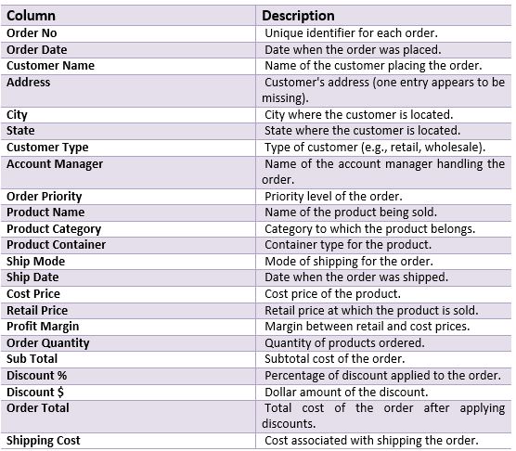The dataset [45] gave is a manufactured portrayal of sales information for an organization, including 5000 entries and highlighting 24 columns. It incorporates different parts of sales transactions, encompassing order details, customer information, and product specifications, pricing, and shipping details. The following is a far-reaching breakdown of every segment:

Figure 1 Dataset Description

## 3.1 Dataset Characteristics:

The dataset presents a different exhibit of information types, encompassing both unmitigated and mathematical information. It highlights transient information addressed by "Order Date" and "Ship Date" sections in date time format. Certain segments, for example, "Cost Price," "Retail Price," and others connected with financial qualities are right now put away as items, recommending a possible requirement for transformation to work with exact mathematical investigation. Generally speaking, the dataset offers a complete depiction of the sales cycle, delivering it reasonable for many scientific and exploratory undertakings.

## 3.2 Load Dataset:

To load the dataset into a Google Collab notebook, we can use the strong capacities of Python libraries like Pandas. In the wake of uploading the dataset document to the Collab climate or giving a connection to its area, we can import the Pandas library and utilize the 'read_csv()' capability to peruse the dataset into a Pandas Data Frame. This interaction commonly includes executing a couple of lines of code, guaranteeing consistent admittance to the dataset inside the Collab climate. Also, google Collab gives advantageous highlights to information investigation and control, empowering clients to proficiently break down the dataset utilizing different Python libraries and perception instruments. By following these means, specialists and examiners can undoubtedly bridle the dataset's bits of knowledge and perform adroit investigations straightforwardly inside the Collab notebook environment.

## 3.3 Data Preprocessing:

Data preprocessing is a significant stage in the data analysis pipeline, including a progression of tasks aimed at cleaning and transforming crude data into a format reasonable for additional analysis and modelling. One normal preprocessing task is taking care of missing qualities, where we really want to recognize and choose how to manage any fragmented or invalid sections in the dataset. This can include methods like dropping lines or sections with missing qualities, or attributing those utilizing factual measures like mean, median, or mode. One more important part of preprocessing includes dealing with categorical factors. Since many AI algorithms require numerical information sources, categorical factors should be encoded properly. This should be possible through methods like one-hot encoding, where every category is changed over into a binary vector, or name encoding, where every category is planned to a numerical value. Numerical features may likewise expect scaling to guarantee that they are on a comparable scale, as features with bigger sizes can disproportionately impact the model. Normal scaling strategies incorporate Min-Max scaling, which resales features to a predefined reach, and normalization, which scales features to have a mean of 0 and a standard deviation of once preprocessing is finished, it's fundamental for split the data into training and testing sets to assess the performance of AI models. This surveys how well the model sums up to concealed data and gives experiences into its viability in true situations. Overall, data preprocessing is a basic move toward the data analysis workflow, as it guarantees the quality, dependability, and reasonableness of the data for downstream undertakings like modelling and expectation. Via cautiously preprocessing the data, examiners can moderate likely issues and inclinations, prompting more accurate and vigorous outcomes.

## 3.4 Exploratory Data Analysis:

Exploratory Data Analysis (EDA) is a critical stage in the data analysis process that includes gaining experiences, recognizing models, and understanding the fundamental development of the dataset. EDA strategies assist examiners with uncovering associations between factors, see exceptional cases, and evaluate the possibility of the data. One commonplace EDA philosophy is outline assessments, which gives a structure of the central tendency, dissipating, and condition of the data distribution. This combines estimates like mean, focus, standard deviation, and percentiles. Encounters, for instance, histograms, box plots, and disperse plots are moreover head gadgets for understanding the vehicle and relationship between factors. Besides, specialists could analyze relationship between factors through relationship analysis, which assesses the strength and heading of straight relationship between pairs of parts. Moreover, systems like dimensionality decline, can be used to picture high-layered data and recognize fundamental models. Recognizing and taking care of missing qualities is one more basic piece of EDA. Experts need to study the level of missingness in the dataset and pick whether to attribute missing qualities or discard deficient discernments. Attribution systems incorporate mean, middle, mode credit, or more refined techniques. Generally, EDA fills in as the foundation for coming about data analysis tasks, assisting examiners with gaining a significant comprehension of the dataset's characteristics and illuminating choices in regards to data preprocessing, feature designing, and model decision. By completely investigating the data through EDA, examiners can uncover critical bits of knowledge and make more educated decisions generally through the data analysis process.

## 3.5 Model Preparation:

Model preparation is a basic stage in the data analysis venture, where cautious meticulousness can fundamentally influence the performance and viability of AI models. It includes a progression of perplexing advances aimed at setting up the models for outcome in handling the particular main job. At first, experts should cautiously choose the fitting AI algorithms in view of the idea of the issue they are tending to. This choice includes thinking about factors like the sort of data (e.g., structured or unstructured), the desired output (e.g., classification, regression, or clustering), and the fundamental examples inside the dataset. When the algorithms are chosen, the subsequent stage is to design them with appropriate hyper parameters. Hyper parameters are boundaries that control the growing experience of the algorithm, for example, the learning rate in gradient descent or the profundity of a decision tree. Finding the ideal values for these hyper parameters is critical for accomplishing ideal model performance. Strategies, for example, network search, randomized search, or Bayesian enhancement can be utilized to efficiently explore the hyper parameter space and recognize the best blend.

Furthermore, model preparation frequently includes highlight designing, where experts control the information features to upgrade the model's capacity to catch significant examples in the data. This might incorporate strategies like making new features, transforming existing ones, or choosing the most informative features through highlight determination or dimensionality decrease techniques. By fastidiously setting up the models as such, examiners can guarantee that they are exceptional to gain from the data actually and sum up to concealed examples. This establishes a strong starting point for ensuing strides in the data analysis pipeline, like model training, assessment, and sending, at last prompting more accurate and reliable outcomes.

## 3.6 Model Utilization:

Model utilization alludes to the deployment and use of machine learning models to make predictions or surmise experiences from new data. On account of a regression model, which is utilized for foreseeing continuous results, there are different ways it very well may be used relying upon the particular issue and setting. One normal use instance of a regression model is in predictive analytic, where it very well may be utilized to forecast numerical values in view of historical data designs. For instance, in finance, a regression model could be used to foresee stock prices or market patterns. Also, in sales forecasting, regression models can anticipate future sales in light of historical sales data and other pertinent factors, for example, advertising spend, irregularity, and financial indicators.

Regression models can likewise be used in streamlining undertakings, where the objective is to expand or limit a certain goal capability. For example, in supply chain management, regression models can be utilized to upgrade inventory levels by anticipating demand and recognizing the ideal ordering strategies. Besides, relapse models can aid in figuring out the connections among factors and going with data-driven decisions. By taking apart the coefficients and significance levels of indicators in the model, specialists can gain pieces of information into the elements influencing the outcome variable and plan procedures appropriately. By and by, sending a relapse model includes taking care of new data into the trained model and obtaining expectations or bits of knowledge as result. This cycle can be robotized and incorporated into business work processes through APIs or programming applications, permitting associations to utilize the predictive power of relapse models logically dynamic cycles. Generally, the usage of relapse models empowers associations to seek after informed decisions, smooth out cycles, and gain critical experiences from their data.

## 3.7 Model Evaluation:

Model evaluation is an essential stage in the AI work process, giving fundamental bits of knowledge into how well the trained model performs on hid data and its ability to summarize to weighty discernments. Concerning the gave code, the Irregular Woods Regressor model's exhibition is thoroughly studied utilizing commonly used relapse evaluation estimations, including Mean Squared Mistake (MSE) and R-squared (R2). The MSE registers the ordinary squared qualification between the certified and expected values, filling in as an extent of the model's precision in foreseeing nonstop outcomes. A lower MSE shows that the model's expectations are closer to the veritable qualities, reflecting better execution. Then again, R-squared evaluates the extent of change in the objective variable explained by the model. A higher R-squared esteem implies a superior fit between the model and the data, showing that the model catches a bigger piece of the changeability in the objective variable. Moreover, cross-approval is used to study the model's strength and speculation execution by over and over parting the dataset into training and testing sets and assessing the model's presentation on each wrinkle. By leveraging these evaluation metrics and procedures, analysts can gain a comprehensive understanding of the model's strengths, shortcomings, and overall predictive capacity, facilitating informed decision-making and model refinement efforts.

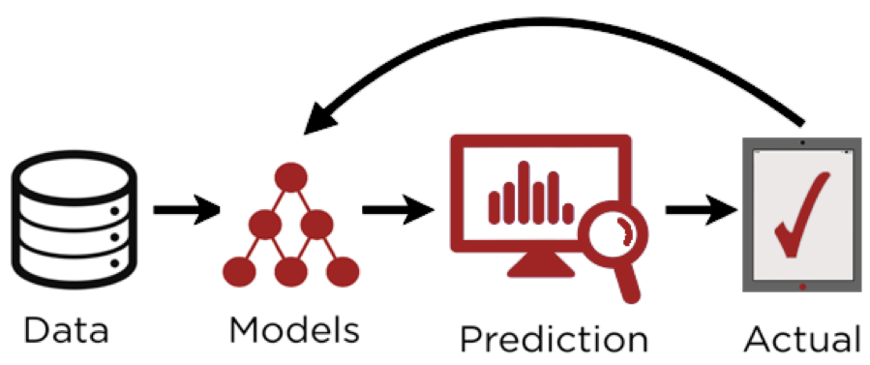

Figure 2 Predicted Modeling

## 3.8 Tools and Technique:

* **Python and Pandas Library**: Python, alongside the Pandas library, offers strong capacities for information control and examination. Utilizing Pandas' read_csv () capability, specialists can productively stack the dataset into a Pandas Information Edge, working with simple access and control of the information inside the Jupiter environment.
* **Jupiter Notebook:** gives a helpful and collaborative environment for data analysis and manipulation
* **Data Preprocessing Libraries:** Different Python libraries, for example, Scikit-learn offer functionalities for data preprocessing assignments like handling missing qualities, encoding unmitigated factors, and scaling mathematical elements. These libraries smooth out the data preprocessing pipeline and guarantee data quality and dependability.
* **Visualization** Tools like Matplotlib and Seaborn grant experts to picture data spreads, associations among variables, and models inside the dataset. Portrayals aid in exploratory data analysis and give encounters, as a matter of fact.
* **Machine Learning Libraries:** Libraries like Scikit-learn give a broad assortment of AI calculations and tools for model availability, training, and evaluation. Experts can utilize these libraries to accumulate predictive models and assess their show.

# Chapter 4

# System Implementation

Implementing AI-powered predictive analytic in the market area includes a complex methodology enveloping information procurement, model turn of events, organization, and continuous maintenance. This cycle is fundamental for utilizing the capability of man-made reasoning to extricate significant experiences from huge volumes of market information, accordingly improving dynamic cycles and driving business development. The execution venture starts with an exhaustive comprehension of the association's information scene and business targets. It entails distinguishing significant information sources, for example, deals exchanges, client cooperation, stock records, and outer market information, and laying out hearty information pipelines for consistent information incorporation. When the information infrastructure is laid out, the center movements to display advancement and training. This phase includes choosing proper AI algorithms, such as regression, classification, or clustering, based on the particular use cases recognized for predictive analytic in market. Information researchers and investigators work cooperatively to preprocess the information, handle missing qualities, encode unmitigated factors, and perform highlight designing to separate significant bits of knowledge. Consequently, AI models are trained on authentic information to learn examples, connections, and patterns that can be utilized to make forecasts or streamline business processes. After thorough validation and testing, including execution evaluation and model tuning, the organization phase starts. In this stage, the trained AI models are coordinated into creation conditions and consistently associated with existing business sector systems, such as point-of-sale systems, stock administration stages, customer relationship management (CRM) software. This incorporation guarantees that the predictive analytic arrangements can produce continuous bits of knowledge and suggestions to help different business capabilities, including request forecasting, estimating enhancement, stock administration, and client division. Constant checking, upkeep, and client preparation are critical parts of structure execution to ensure the steadfastness, adaptability, and gathering of simulated intelligence-driven prescient scientific game plans in the market business. Checking incorporates following the show of sent models, distinguishing anomalies or floats in data models, and making significant acclimation to keep up with ideal execution. Support combines strengthening models with new data, retraining models irregularly to adjust to changing monetary conditions, and settling a particular issues or framework dissatisfaction. Client getting ready and assembling are standards for engaging retail social occasions to use judicious logical instruments, unwind model results, and integrate data-driven snippets of data into their dynamic cycles. Plus, spreading out an info circle for iterative improvement is essential for updating the accuracy and meaning of prescient insightful models for a long time. This incorporates mentioning analysis from end-clients, taking apart model execution estimations, and iteratively refining models given new encounters and business necessities. By continually rehashing and chipping away at the prescient scientific structure, retailers can stay before market patterns, expect client needs, and drive manageable business improvement.

## 4.1 Data Acquisition and Integration:

During the system execution stage, the fundamental course of data getting and coordination turns into the predominant point of convergence, laying out serious areas of strength for a point for the use of man-made intelligence-driven prescient scientific in the market region. The outing begins with a picky evaluation pointed toward perceiving a scope of data sources that hold the likelihood to yield huge encounters dire for market information. This exhaustive chase navigates across various channels, incorporating inside data sets, deals records, client analysis channels, electronic amusement stages, and outside data providers. At the point when the significant sources are pinpointed, the middle developments towards the underpinning major areas of strength for pipelines. These pipelines act as the foundation of the information infrastructure, coordinating the consistent progression of data from unique sources to a unified vault or information distribution center. Via mechanizing the extraction, transformation, and loading (ETL) processes, these pipelines guarantee the effective handling and stockpiling of information, laying the preparation for ensuing investigation. Besides, the excursion of information preprocessing unfurls, where the crude information goes through a progression of purging and refinement strategies to address any blemishes or irregularities. Procedures such as information attribution, exception location, standardization, and standardization are utilized to upgrade the quality and respectability of the dataset. This fastidious information preparing process is fundamental for guaranteeing the unwavering quality and exactness of ensuing insightful undertakings. Besides, the combination of different datasets into a brought together information stage or information lake arises as a vital stage in empowering far reaching examination. By combining information from numerous sources into a strong system, associations gain a comprehensive point of view of market elements, client ways of behaving, and functional patterns. This incorporated methodology engages market players to extricate significant experiences and settle on informed choices that drive business development and intensity. By saddling the force of brought together information, associations can open new open doors, moderate dangers, and upgrade functional efficiencies. Furthermore, the consistent admittance to thorough datasets works with nimble navigation, empowering associations to answer quickly to developing business sector patterns and purchaser inclinations. As associations set out on their excursion towards AI-driven predictive analytic, the strong groundwork laid during the information securing and mix phase fills in as a foundation for progress in the unique market landscape.

## 4.2 Infrastructure Setup and Configuration:

As associations dive into the framework execution phase, a urgent aspect includes the arrangement and design of the fundamental infrastructure to help the sending of AI-driven predictive analytic in the market area. This try starts with the cautious choice and sending of figuring infrastructure tailored to fulfill the computational needs of information handling, model training, and organization. Associations might select versatile registering arrangements, such as cloud-based services offered by suppliers like Amazon Web Services (AWS), Microsoft Azure, or Google Cloud Platform (GCP), or on the other hand, they might decide to put resources into on-premises servers. The picked infrastructure ought to focus on factors like adaptability, dependability, and cost-viability, lining up with the association's particular necessities and monetary contemplation. Besides, the foundation of development environments assumes a significant part in working with the creation and refinement of AI models.These conditions are equipped with a set-up of crucial programming instruments and libraries essential for data assessment, man-made intelligence model turn of events, and association. Key pieces of these conditions consolidate programming vernaculars like Python, which fills in as a general choice for man-made intelligence improvement, and nearby man-made intelligence designs, for example, TensorFlow and PyTorch. Besides, coordinated improvement conditions (IDE) like Jupiter Scratchpad or Visual Studio Code are instrumental in enabling helpful turn of events and experimentation, giving a bound together stage to coding, investigating, and variation control. Besides, strong data stockpiling frameworks structure the foundation of the foundation, ensuring capable organization and accessibility of immense measures of coordinated and unstructured data. Associations could convey a grouping of stockpiling courses of action, going from conventional social data sets to No SQL information bases or dispersed document frameworks. These capacity frameworks are picked considering their ability to scale reliably, stay aware of data decency, and keep up with extreme security standards. By spreading out flexible data stockpiling instruments, associations lay the foundation for putting away, recuperating, and taking apart data essential to driving educated direction and procuring huge pieces of information into market patterns and purchaser conduct.

## 4.3 Model Development and Training:

In the space of market logical, model development and planning are basic stages highlighted handling the power of man-made intelligence calculations to eliminate significant pieces of information from data. The interaction starts with algorithm determination, where proper AI algorithms are picked in view of the particular goals of prescient analytic, for example, request forecasting, client division, or item suggestion. Factors like information intricacy, interpret-ability, and the idea of the issue guide the determination interaction. Following algorithm determination, highlight designing assumes a pivotal part in upgrading model performance by separating pertinent elements from crude information. Methods like element scaling, dimensionality decrease, and cooperation term creation are utilized to catch significant examples and connections inside the information. Whenever highlights are designed, the models are prepared on historical information utilizing administered, solo, or semi-managed learning methods. The information is parted into preparing and approval sets, and cross-approval procedures are applied to assess and streamline model performance. Calibrating of model hyper-parameters further upgrades exactness, accuracy, review, or other performance measurements, guaranteeing that the models really catch basic examples and connections in the information.

## 4.4 Validation and Testing:

After model development and training, validation and testing are basic moves toward assess the vigor and speculation capacity of the models. Cross-validation procedures like k-fold cross-validation or stratified cross-validation are used to approve model performance across various subsets of the information, assisting with identifying and alleviate overfitting. Moreover, prepared models are assessed on a different test set of information that was not utilized during training to gauge their performance on certifiable information. Performance metrics such as accuracy, precision, recall, F1-score, or area under the ROC curve (AUC) are determined to measure model performance and look at changed models. The decision of performance metrics relies upon the particular business targets and use cases, guaranteeing that the models successfully address the necessities of the market analytic area.

## 4.5 Deployment and Integration:

Whenever models are trained and validated, they are deployed into creation conditions utilizing versatile and dependable arrangement frameworks such as containerization or server less figuring. Robotized sending processes guarantee repeatability and limit organization errors and personal time. Besides, judicious scientific plans are perfectly integrated with existing business sector frameworks, including deal area frameworks, stock-the-board frameworks, CRM programming, and web business stages. This blend engages progressing data exchange and allows retailers to utilize judicious encounters across their entire assignments. Continuous pieces of the information age are a critical part of the association, ensuring that farsighted models can give fortunate propositions to various business works, for example, demand gauging, assessing smoothing out, stock the board, and client division. Streaming data handling techniques are used to handle high-velocity data streams and make important pieces of information that drive information powerful in the exceptional market environment.

## 4.6 Monitoring and Maintenance:

In the strong landscape of market science, predictable observing and backing of judicious logical models are crucial to ensure their sufficiency and steadfastness for a long time. Spreading areas of strength for our frameworks is the underlying step, engaging associations to follow model execution measurements, recognize quirks or floats in data scattering, and trigger alerts for model retraining or re-adjustment as vital. By dependably noticing key execution pointers (KPIs) and model estimations, affiliations can proactively see any deviations from the speculated approach to acting and take medicinal activities to remain mindful of the accuracy and possibility of their farsighted models. Standard assistance endeavors are additionally central to stay aware of the show and adaptability of wise quick plans. These tasks incorporate routine information restores, model retraining, programming updates, and framework fortifications. By executing automated pipelines for information ingestion, preprocessing, model arrangement, and game-plan, affiliations can smooth out help cycles and cutoff manual mediation, guaranteeing that their prudent clever plans stay bleeding edge and reliable. Settling explicit issues quickly is another key piece of construction support.Associations should spread out shows to explore ordinary issues, elevate fundamental issues, and plan responses across cross-valuable gatherings to restrict extra energy and stay aware of business movements. By rapidly settling specific issues and structure frustrations, associations can alleviate unsettling influences on their judicious scientific work processes and ensure the persistent action of their market insightful frameworks.

## 4.7 Feedback Circle and Iterative Improvement:

Finally, spreading out an input circle and embracing iterative improvement are central for refining insightful logical models and constantly overhauling their practicality. Associations should spread out instruments for social event client input, observing model execution measurements, and perceiving regions for improvement. End-clients should be encouraged to give criticism on the convenience, significance, and precision of judicious insightful game plans, which can be used to coordinate iterative refinements and redesigns. Iterative refinement incorporates using input from end-clients and execution measurements to redesign farsighted logical models, data pipelines, and sending processes. Organizations can explore different avenues regarding new algorithms, highlights, or information sources to work on model accuracy, interpret-ability, and business influence. By taking on light-footed development strategies and embracing a culture of persistent improvement, organizations can iteratively refine their prescient analytic answers for meet developing business needs and drive supportable development in the market business

# Chapter 5

# Implementation

This project can be carried out utilizing various devices and structures, giving many potential components and models. The accompanying components are utilized in the project.

**Collab Notebook:** A flexible environment for programming Libraries: For further developed usefulness, utilize libraries like NumPy and pandas.

**Matplotlib and Seaborn:** Use these computer programmers to make charts.

**Machine Learning algorithm:** Inspect various models for machine learning, like Random Forest, MLP, SVM, and KNN. The project code is partitioned into discrete segments, each given to a specific model that was utilized during the time spent execution

## 5.1 Research Plan and Task Lists

In the domain of machine learning, the quality and dependability of information are principal for the adequacy of any model. This involves a careful information planning process, encompassing fundamental stages such as element designing, transformation, and information sifting. By carefully setting up the information, we guarantee that it is appropriate for top to bottom investigation, empowering the development of exact expectations and adroit ends. Inside the setting of picture examination, these vital parts are of most outrageous significance. We use an alternate show of instruments and procedures to isolate critical components from pictures, change the data into a sensible configuration for assessment, and channel out any upheaval or exemptions that could block model performance. Through this thorough approach to managing data course of action, we hope to handle the greatest limit of AI to open significant encounters and drive critical decisions in various regions.

## 5.2 Data Cleaning Process:

Data cleaning is a sincere piece of the AI work process, key for guaranteeing the quality and relentlessness of the dataset utilized for model planning. This cycle solidifies a few stages highlighted setting up the data for evaluation and model turn of events. At every turn, missing qualities are addressed through systems like attribution or dropping to remain aware of the legitimacy of the dataset. Copy records are seen and taken out to forestall tendency and plain dullness in the appraisal. Irregularities are seen and managed fittingly to keep them from ridiculously impacting model execution.Hard and fast factors are encoded into numerical arrangement to make them conceivable with AI calculations, while numerical parts are scaled to a near reach to forestall lopsided effect during model status. Solidify orchestrating techniques may be applied to make new features or change existing ones, managing the brilliant power of the model. Also, class disparity issues, in the event that present, are watched out for through oversampling or under-testing approaches. At long last, the dataset is isolated into planning, approval, and test sets to study model execution. By fundamentally tidying and setting up the data, analysts can guarantee that their AI models are ready on incredible data, inciting more precise and solid expectations.

## 5.3 Data Splitting:

Data splitting is a focal stage in the machine learning work process, including dividing a dataset into specific subsets to work with model preparation, validation, and testing. The dataset is regularly divided into three chief sets: the preparation set, used to set up the model by introducing it to stamped data and allowing it to learn models and associations; the validation set, used to adjust the model's hyper-boundaries and survey its performance during preparing, in this manner thwarting overfitting; and the testing set, used to evaluate the model's keep going performance on covered data, giving encounters into its hypothesis limits. It is important to play out the data parsing process randomly to hinder predisposition and assurance the subsets are illustrative of the entire dataset. Normal splitting proportions, such as 70-15-15 or 80-10-10, allot the majority of the data to the training set while saving more modest proportions for validation and testing. By rigorously executing data splitting strategies, experts can prepare, approve, and assess machine learning models actually, eventually prompting more exact and dependable predictions in genuine applications.

## 5.4 Machine learning Algorithm:

Machine learning algorithms are significant parts of present-day data investigation and prescient modeling, filling in as useful assets for extricating significant bits of knowledge and making exact predictions from complex datasets. Among the different cluster of machine learning algorithms accessible, two stand out as generally utilized and exceptionally compelling: Random Forest and Linear Regression

**Random Forest:**

Random Forest stands out as a profoundly flexible and generally used ensemble learning method in the domain of machine learning. Its standing for generosity and adaptability is justified, as it shows noteworthy performance across an extensive variety of datasets and errands. At its center, Random Forest works by building different decision trees during the preparation stage, each uninhibitedly learning from a subset of the data and making predictions. Consequently, the consequences of these particular trees are gathered to convey a last estimate, achieving redesigned precision and solidness. One of the vital characteristics of Random Forest lies in its ability to handle awesome, high-layered datasets that consolidate both unmitigated and numerical components. Dissimilar to a couple of different calculations, Random Forest requires inconsequential data preprocessing and is prepared for obliging missing characteristics without huge loss of exactness. Besides, its characteristic part of bootstrapping and feature randomization enables it to effectively ease the gamble of overfitting, a regular snare in machine learning models. Besides, Random Forest gives critical encounters into incorporate significance, allowing inspectors to recognize the most convincing elements inside a dataset. This part is especially basic in understanding the secret models and relationship inside the information, working with informed course and hypothesis age. Plus, Irregular Woods is versatile in its congruity, being legitimate for a huge number of endeavors including request, fall away from the faith, and part affirmation. Irregular Woodland has gotten its remaining as a key contraption in the AI save because of its power, versatility, and adaptability. Its capacity to deal with various datasets, ease overfitting, and give experiences into consolidate importance seeks after it a leaned toward decision for information researchers and experts across different spaces. As AI keeps on making, Irregular Woods extra parts an establishment estimation, engaging specialists to dispense with basic experiences and make precise expectations from complex datasets.

**Ridge Regression:**

Ridge Regression is a regression technique that fills in as an answer for two conventional issues in direct regression: multicollinearity and overfitting. By no means like standard direct regression, which checks coefficients utilizing the typical least squares strategy, Ridge Regression adds a discipline term to the regression objective limit. This discipline term, obliged by a hyper-limit λ, rebukes immense coefficients, successfully contracting them towards nothing. Hence, Ridge Regression keeps an eye out for multicollinearity by off setting the coefficient checks, as well as overfitting by putting pointlessly complex models down. The decision of λ is central, as it oversees the put down some a reasonable compromise between fitting the planning information well and keeping the model fundamental. A more humble λ permits the model to immovably fit the preparation data yet may provoke overfitting, while a greater λ upholds less troublesome models with additional unobtrusive coefficients. Overall, Ridge Regression gives a congruity among inclination and variance, making it a huge gadget for dealing with the energy and hypothesis execution of straight regression models in evident applications.

**SVM Regression:**

Support Vector Machine (SVM) Regression is areas of strength for a used for regression errands, hoping to find the hyperplane that best fits the data while expanding the edge between data of interest. Not at all like regular direct regression methodologies that intend to restrict assumption bumbles, SVM Regression bases on fitting anyway numerous data of interest as would be reasonable inside a predefined edge. This edge is the distance between the hyperplane and the nearest snippets of data, known as help vectors. SVM Regression utilizes a mishap capacity that rebuffs data of interest outside the edge, with ordinary hardship abilities including e-harsh setback and quadratic misfortune. Besides, it integrates a regularization boundary (C) to control the concordance between expanding the edge and restricting the quadratic misfortune.SVM Regression can deal with non-direct connections among elements and target factors using bit capabilities like linear, polynomial, radial basis function (RBF), and sigmoid kernels. By and large, SVM Regression is hearty, especially in high-layered spaces, and can really catch complex connections among elements and target factors. Be that as it may, it might require cautious tuning of hyper-parameters for ideal execution.

# Chapter 6

# DISCUSSION EVALUATIONS

## 6.1 Code:

This section provides a thorough explanation of the experiment, going into great detail about every tactic, technique, and instrument used. The objective is to provide a comprehensive understanding of the instruments employed and the procedural actions conducted during the experiment.

**6.2 Code Setup:** In this section, the methods used to predict the result. Models are trained using a Jupiter notebook (likely a Jupiter Notebook) using a dataset. The apparatus, platforms, and data sources that will be used throughout the experiment are listed in more detail in the experimental setup.

**6.3 Code Design/Details:** In this section, we will investigate the innovative utilization of artificial intelligence (AI) to alter market intelligence in the market area. Our emphasis will be on a state-of-the-art innovation that empowers customized purchaser experiences without depending on customary strategies. We will examine the plan and execution of this innovation, underlining changing business sector operations potential. Errands associated with this interaction incorporate coordinating AI systems, model turn of events, thorough testing, and prescient examination. This portion fills in as both a far-reaching outline of our methodology and a down to earth guide for executing comparable techniques in other market settings.

**6.4 Import the necessary libraries:** A significant initial phase in the trial-and-error process is to incorporate the fundamental libraries. The significance of ensuring your code incorporates every important library and conditions couldn't possibly be more significant. These libraries ordinarily give the instruments expected to different errands, including dealing with information, handling records, advancing models, picturing information, and that's only the tip of the iceberg. After these libraries are effectively imported, you can continue on toward the following phases of the trial.

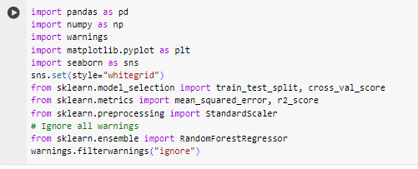

Figure 3 Load Libraries

**6.6 Load Dataset:** The dataset "data.xlsx" has been stacked into a Pandas Data Frame named "df" utilizing the 'read- excel' capability from the Pandas library. Using the 'data ()' technique on the Data Frame gives a brief rundown of its construction, offering experiences into the dataset's size, segment names, information types, and memory utilization. This data is significant for grasping the dataset's basic qualities and for pursuing informed choices in regards to information control, examination, and demonstrating. By acquiring an outline of the dataset's properties, investigators and information researchers can actually design their work process and address any likely issues or inconsistencies inside the information. With this fundamental information close by, further investigation and examination of the dataset can be embraced to remove significant bits of knowledge and drive informed dynamic cycles.

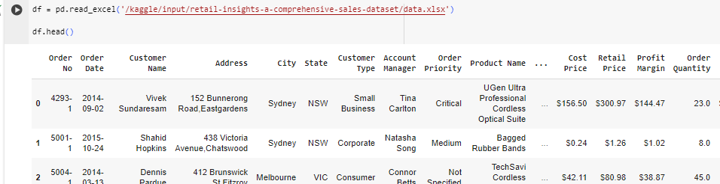

Figure 4 Load Dataset

**6.7 Augmenting Data and Preprocessing:**

Data preprocessing is a basic move toward preparing a dataset for analysis and modeling, guaranteeing that it is perfect, steady, and reasonable for the expected purposes. In the gave code scrap, a few preprocessing procedures are applied to the dataset "df" to upgrade its quality and convenience. At first, explicit columns considered pointless for analysis, for example, 'Order No', 'City', 'State', 'Customer Name', and 'Address', are dropped from the Data Frame utilizing the drop () technique. Moreover, lines with missing qualities in the 'Order Quantity' segment are removed utilizing the dropna () strategy. Then, date highlights are extricated from the 'Order Date' and 'Ship Date' columns, including the day of the week and the period of the order and shipment dates. These elements can give significant experiences into fleeting examples and patterns inside the data. Straight out columns are then one-hot encoded utilizing the get_dummies () capability, changing over them into mathematical portrayals for AI calculations to successfully process. Besides, money related columns containing dollar signs are switched over completely to numeric data types by eliminating the dollar signs and constraining the qualities to numeric utilizing a for circle and the pd.to_numeric () capability. This guarantees that these columns are treated as mathematical elements instead of strings, working with numerical tasks and analysis. At last, extra columns, for example, 'Order Date', 'Product Name', and 'Ship Date', which are no longer required subsequent to preprocessing, are dropped from the Data Frame. Any remaining lines with missing qualities across all columns are additionally dropped to guarantee data fulfillment. By methodically playing out these preprocessing steps, the dataset is changed into a spotless, organized design prepared for analysis, modeling, and separating important experiences to drive decision-making processes in the retail domain.

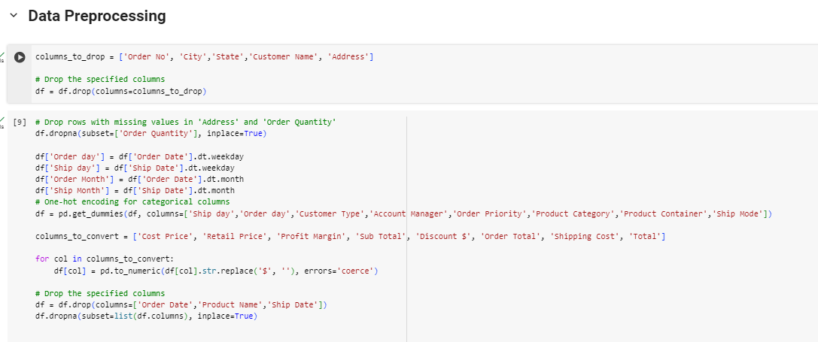

Figure 5 Data Preprocessing

**6.8 Scaling Data:**

The emphasis is on visualizing the correlation between numeric columns inside a dataset, especially with regards to showcase exchanges. The code starts by indicating a rundown of numeric section names, which probably address different parts of retail exchanges like estimating, amounts, limits, and all out costs.While the code cycle doesn't explicitly perform data scaling, which is a run of the mill preprocessing step in man-made intelligence work processes, it stresses getting a handle on the connections between these numeric highlights. By calculating a connection network using the 'Corr()' strategy and envisioning it as an intensity map with explanations using Seaborn, the code engages specialists to quickly perceive models and conditions between different elements. This portrayal helps with uncovering pieces of information that can enlighten dynamic cycles, for instance, recognizing which highlights have the most grounded connections or understanding what changes in a solitary component could mean for others. By and large, the code bit works with a more significant perception of the crucial plan of the dataset, laying the preparation for extra examination and modeling in the retail space.

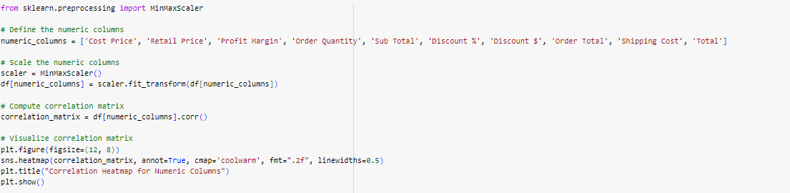

Figure 6 Scaling

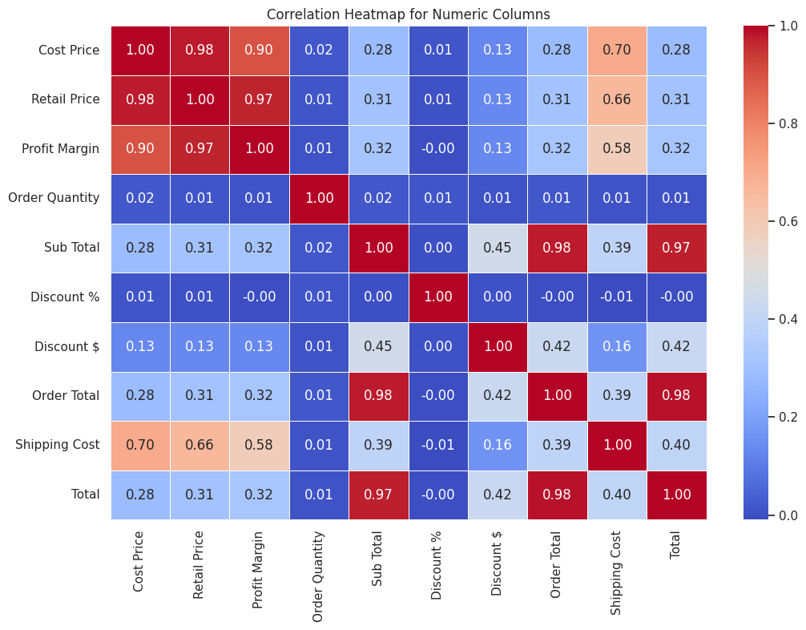Figure 7 Correlation

**6.9 Exploratory Data Analysis**

**Visualization of Categorical Variables in the Dataset**

**Product Category Distribution:** Understanding the assortment and prominence of products is urgent in market analysis. The count plot displaying the distribution of products across various categories offers important experiences into the collection of things available inside the dataset. By visualizing the recurrence of products inside every category, partners gain a thorough comprehension of which product categories are more pervasive or well known. This knowledge aids in recognizing patterns, deciding stock administration methodologies, and enhancing advertising endeavors. Furthermore, it gives a premise to evaluating the interest for explicit product types and making informed decisions with respect to product obtaining, valuing, and limited time exercises. Generally, the representation of product category distribution fills in as a central device for retailers to deal with their product contributions and improve customer fulfillment successfully.

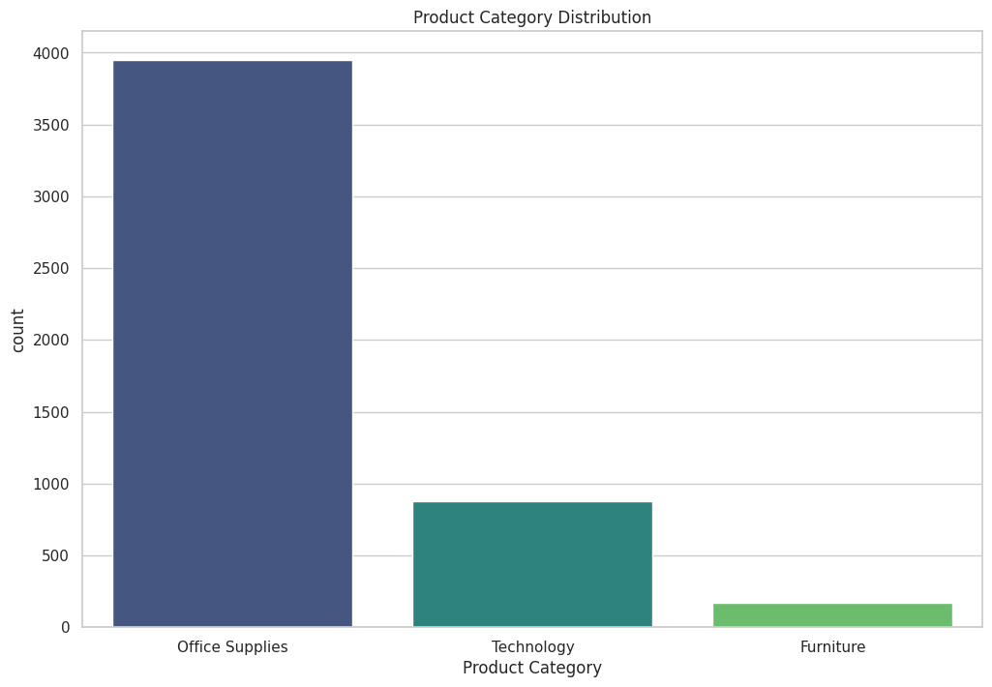

Figure 8 Product Category Distribution

**Order Priority Distribution:** Effective order the executives are fundamental for any market activity, and understanding the distribution of orders in view of their need levels is critical to advancing this cycle. The count plot outwardly addresses the distribution of orders across various need levels, as shown by the straight-out values in the 'Order Priority ' segment, for example, 'High', 'Medium', or 'Low'. Investigating this distribution offers experiences into the responsibility distribution and the general significance of various sorts of orders inside the dataset. For example, a higher recurrence of 'High' need orders might recommend a requirement for facilitated handling or exceptional dealing with, while a higher extent of 'Low' need orders might show normal or less earnest exchanges. By understanding the distribution of order needs, retailers can dispense assets all the more productively, focus on assignments appropriately, and further develop by and large order satisfaction processes.

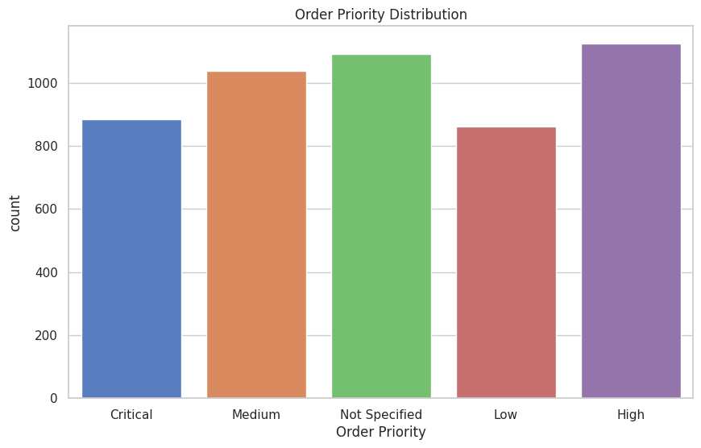

Figure 9 Order Priority Distribution

**Ship Mode Distribution:** The decision of shipping mode assumes a basic part in conveying products to customers in a convenient and financially savvy way. The count plot portraying the distribution of shipping modes used in retail exchanges gives significant experiences into the coordinated factors and delivery methodologies utilized by the retail activity. The 'Ship Mode' section probably contains straight out values addressing different shipping techniques, for example, 'Standard Shipping', 'Express Shipping', or 'Next-Day Delivery'. Breaking down the distribution of shipping modes assists retailers with figuring out the favored delivery choices among customers and recognize any patterns or examples in shipping inclinations. This knowledge empowers retailers to tailor their shipping strategies, enhance delivery courses, and haggle better shipping rates with transporters. Moreover, understanding the distribution of shipping modes permits retailers to give precise delivery assessments to customers, upgrade the general shopping experience, and assemble trust and faithfulness. Every one of these count plots offers significant experiences into the absolute factors present in the dataset, revealing insight into the distribution and examples inside these factors. By utilizing these bits of knowledge, retailers can go with data-driven choices and execute systems to work on different parts of their tasks, including product the board, order handling, and shipping coordinated operations. At last, these educated decisions add to a more effective and customer-driven retail insight, driving development and outcome in the cutthroat retail scene.

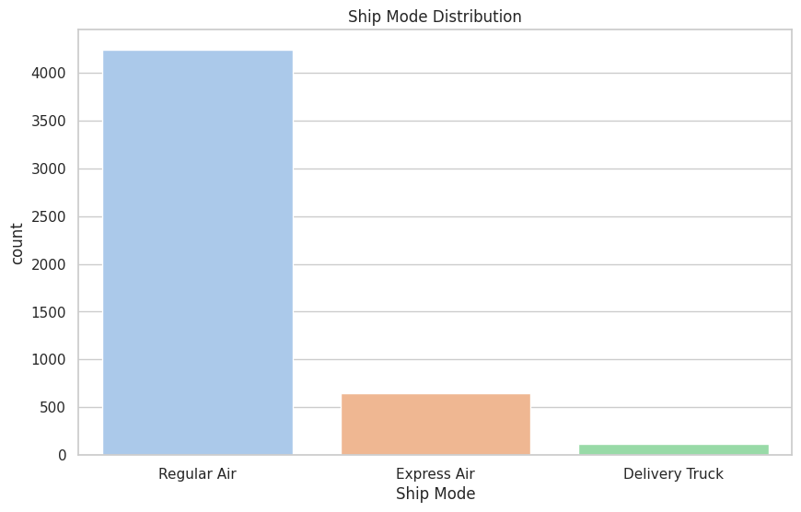

Figure 10 Ship Mode Distribution

**Histogram for Cost Price Distribution:** The histogram gives a visual representation of the distribution of cost prices for products inside the dataset. The 'Cost Price' column probably contains mathematical qualities addressing the cost brought about by the retailer to secure or create every product. By binning the cost prices into 20 spans and plotting the recurrence of event for every stretch, the histogram uncovers experiences into the spread and focal inclinations of cost prices across the dataset. The presence of a bit thickness gauge (KDE) bend improves the representation by portraying the fundamental likelihood thickness capability of the data. This perception aids in distinguishing normal cost price ranges, identifying any skewness or anomalies in the distribution, and understanding the general cost construction of the products presented by the retailer. Dissecting the distribution of cost prices is vital for valuing procedures, cost administration, and evaluating the benefit of products, at last directing decisions connected with estimating changes, product obtaining, and stock administration.

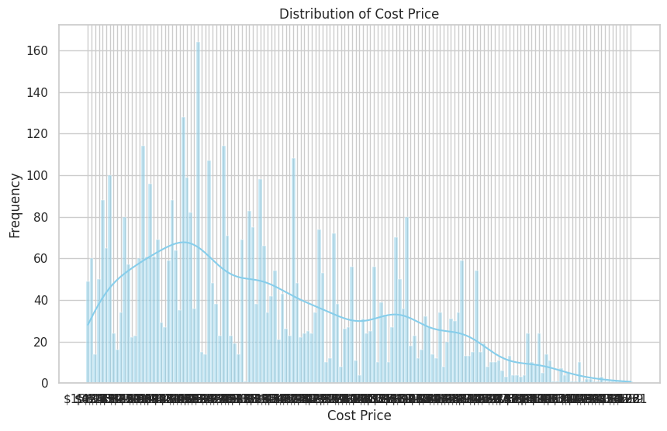

Figure 11 Histogram for Cost Price Distribution:

**Distribution of Numeric Columns:** The first two fundamental visualizations aimed at understanding the distribution and relationships inside the dataset's numeric columns. The primary perception shows histograms for all numeric columns in the Data Frame, exhibiting the distribution of each numerical element separately. By setting boundaries, for example, fig size, bins, edge color, and alpha, the histograms are tailored for clearness and understanding. This perception offers significant experiences into the spread and focal propensities of each numeric component, aiding in recognizing normal examples, distinguishing exceptions, and understanding the by and large distributional attributes of the dataset. The title c briefly typifies the reason for the representation, giving setting and directing translation.

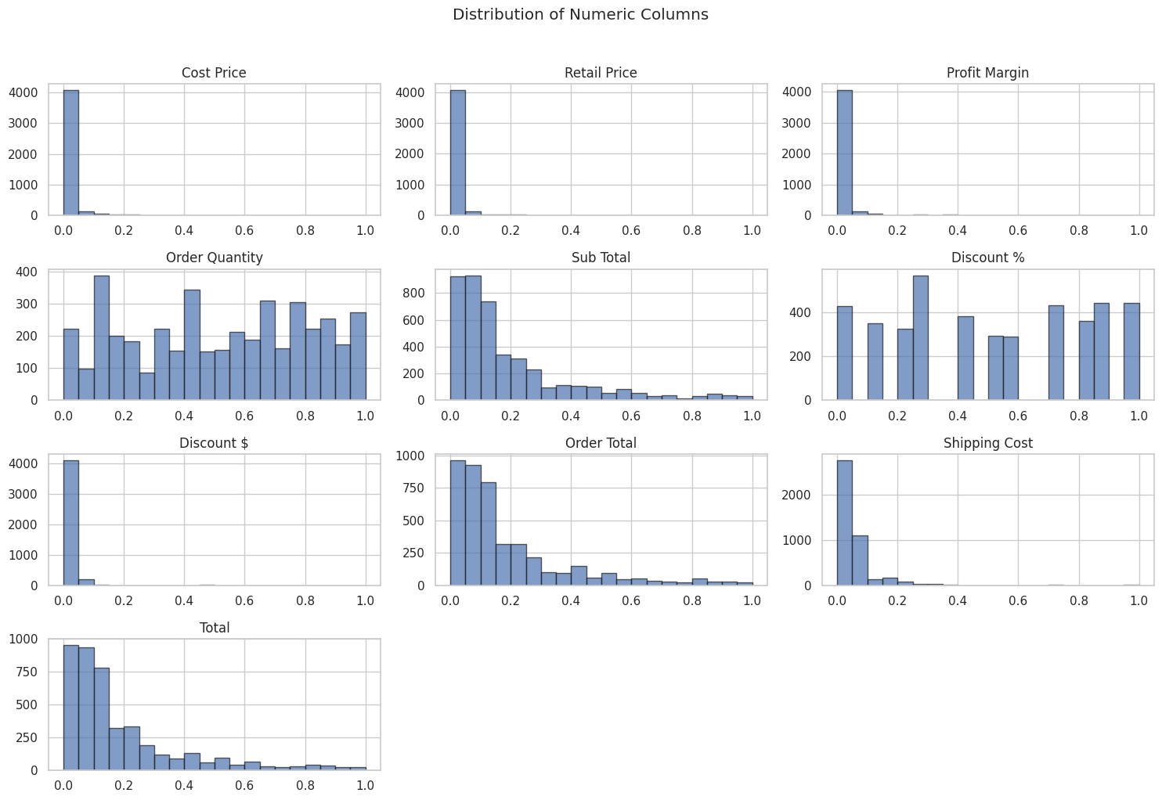

Figure 12 Distribution of Numeric Columns

**Pair plot for Numeric Columns:** The second visualization makes a pair plot for chose numeric columns, introducing scatter plots and histograms for each pair of features. The pair plot capability from the Seaborn library computerizes the formation of a framework of subplots, where each numerical element is plotted against each and every other numerical component. This visualization works with the investigation of relationships and correlations between various numeric columns, considering the ID of likely examples, patterns, and conditions inside the dataset. The title "Pair plot for Numeric Columns" compactly depicts the substance of the visualization, directing the watcher's understanding and accentuating its utility in revealing bits of knowledge about the dataset's design. Together, these visualizations offer a thorough understanding of the numeric parts of the dataset, giving important bits of knowledge that can illuminate ensuing analysis and decision-making processes.

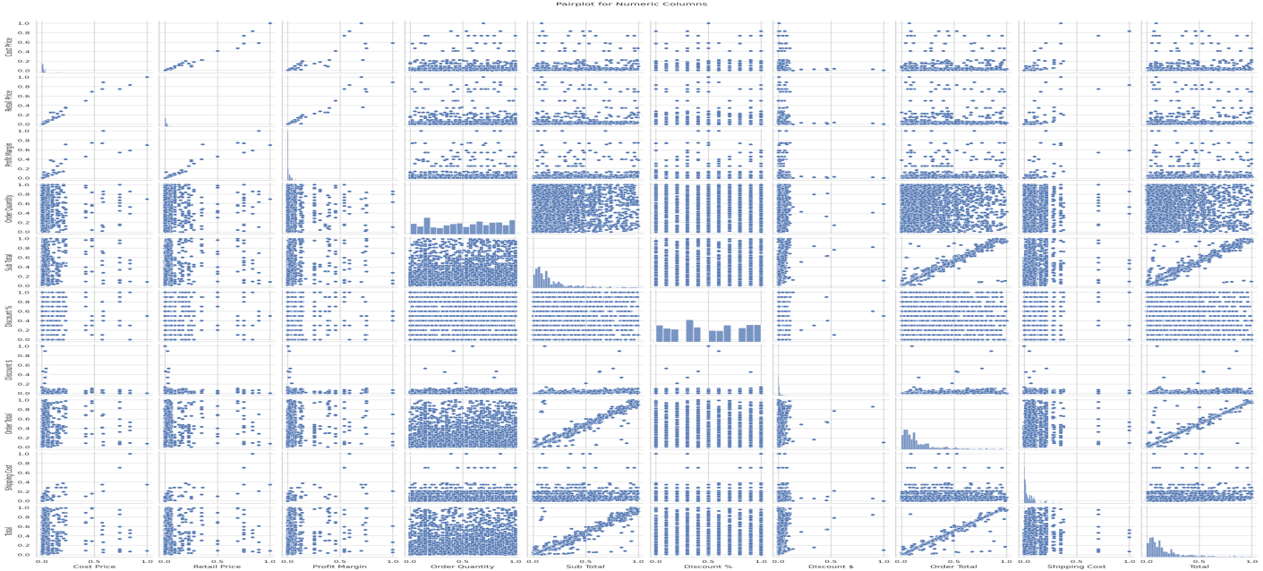

Figure 13 Pair plot for Numeric Columns

**Data Splitting:**

A StandardScaler is used to scale the numerical columns of the Data Frame 'df'. The numerical columns, including 'Cost Price', 'Retail Price', 'Profit Edge', 'Order Quantity', 'Sub Total', 'Discount %', 'Discount $', 'Order Total', and 'Shipping Cost', are chosen for scaling. StandardScaler standardizes the features by eliminating the mean and scaling to unit difference, guaranteeing that the features have a mean of 0 and a standard deviation of 1. When the numerical columns are scaled, the dataset is parted into features (X) and the objective variable (y). The objective variable, 'Total', is isolated from the features. Subsequently, the dataset is separated into training and testing sets utilizing the train_test_split capability from Scikit-learn. The test_size boundary determines the extent of the dataset to remember for the test split, with a test size of 0.2 demonstrating that 20% of the data will be utilized for test. The random_state boundary guarantees reproducibility by fixing the random seed for parting the dataset. This preprocessing pipeline readies the data for AI modeling. By scaling the numerical features and parting the dataset into training and testing sets, the code makes way for training and assessing AI models to anticipate the 'Total' esteem in light of different features in the dataset. The Sklearn. model choice module's train_test_split capability separates the dataset reasonably into training and testing sets. This step is fundamental for determining how well the model performs on information that it hasn't seen during training, which supports determining how well it can sum up. Splitting happens before model training and following the information preprocessing stages. The preprocessed images (X) and the names that relate to them (y) are taken care of into the train_test_split capability. The dataset is separated into two subsets, one for training and the other for testing, and is then randomly rearranged. As indicated by the Test_size boundary, the standard practice is to dole out a particular level of the information — for this situation, 20% — to the testing set.

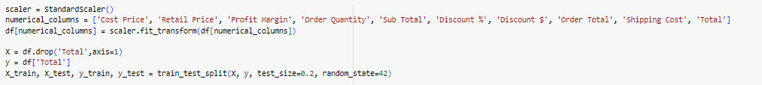

Figure 14 Data Spliting

# Chapter 7:

# Results and Findings:

The outcomes when three unique models are applied are shown in Table 7.1. Each model offers the most elevated level of accuracy. The best testing and it are Ridge regression model to learn strategy. Performance Validation: The performance validation of the three models reveals valuable bits of knowledge into their predictive capabilities and robustness. Starting with the Support Vector Regression (SVR) model, it displays a commendable Mean Squared Error (MSE) of 0.032 and an impressive R-squared value of 0.965 on the test set. Moreover, the cross-validated MSE of - 0.030 and the cross-validated R-squared of 0.969 further bolster trust in its predictive accuracy and generalization capability. Continuing on toward the Random Forest Regression model, it demonstrates a somewhat higher MSE of 0.034 and a marginally lower R-squared value of 0.962 on the test set compared to the SVR model. However, its cross-validated MSE of - 0.038 and cross-validated R-squared of 0.961 attest to its robustness and stability across different subsets of the data.Ultimately, the Ridge Regression model outperforms both SVR and Random Forest Regression models as far as MSE, yielding the most insignificant MSE of 0.025 on the test set. Moreover, it accomplishes the most important R-squared worth of 0.972, demonstrating its better capacity than make sense of the difference in the objective variable. The model's cross-validated MSE of - 0.030 and cross-validated R-squared of 0.970 further approve its prescient performance and speculation ability. In synopsis, while each of the three models major areas of strength for exhibit performance, with R-squared values going from around 0.962 to 0.972, the Ridge Regression model arises as the top entertainer with the least MSE and the most important R-squared values on both the test set and cross-validated measurements. These disclosures highlight the significance of picking the most reasonable regression model in light of the specific necessities of the job that needs to be done, taking into account factors like prescient exactness, speculation capacity, and computational efficiency.

|  |  |
| --- | --- |
| **Model** | **Accuracy** |
| Ridge Regression | 97% |
| SVM Regression | 96% |
| Random Forest | 96% |

## Visualization Comparison Model:

Visualizing the comparison of Mean Squared Mistake (MSE) for each of the three models utilizing a pie diagram gives a reasonable portrayal of the dispersion of blunders across the models. The pie graph uncovers that Ridge Regression holds the smallest portion, with just 27.6% of the absolute blunder, showing its moderately lower MSE contrasted with different models. Then again, Random Forest Regression involves the biggest section, comprising 37.4% of the all-out blunder, proposing a relatively higher MSE for this model. In the meantime, SVR is in the middle, addressing 35.1% of the complete blunder. This perception successfully outlines the overall performance of each model as far as expectation precision, making it more strengths to recognize their assets and weaknesses.

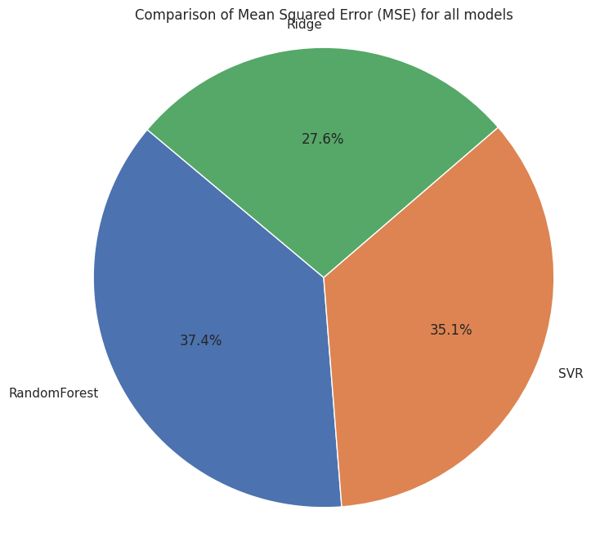

Figure 15 Visualization Comparison

Risk Assessment and Management

AI-Powered Market Intelligence puts up forward a trans-developmental methodology for sale to the public investigation, yet different difficulties might arise all through the examination cycle, possibly influencing project results. These difficulties include potential security breaks, specialized obstacles, moral quandaries, and lawful consistence. To address these difficulties proactively, vital measures will be carried out:

* Security Insurance
* Technical challenges
* Ethical concerns
* Legitimate Consistence

**Security Insurance:** Guaranteeing the secrecy of member data and obtaining informed consent will be fundamental needs. Thorough testing and cautious model arrangement will be used to alleviate specialized gambles, for instance, predisposition and data handling issues.

**Ethical Concerns:** Maintaining ethical standards and focusing on member protection will be basic all through the exploration. Ethical contemplation and data security will assume a urgent part in dynamic cycles.

**Legitimate Consistence:** Adherence to significant guidelines overseeing the variety and use of individual data for facial acknowledgment innovation will be completely complied with. Consistence with legitimate frameworks will be a fundamental piece of the investigation cycle. Specialized Difficulties: Tending to worries associated with model accuracy, possible inclinations, and other specialized intricacies is basic. Normalized computation testing, approval frameworks, and wearisome improvement tries will be essential systems to overcome these hindrances. An intensive bet the board plan will be formulated to address these difficulties deliberately. This plan will move toward frameworks for perceiving, reviewing, and mitigating threats to ensure that the investigation is driven safely, morally, and as per authentic principles. By proactively tending to expected specialized difficulties nearby security, moral, and genuine consideration, the assessment plans to foster a strong and reliable environment for organizing facial affirmation research in the retail region.

# Chapter 8

# Conclusion

The evaluation of the Random Forest Regression, Support Vector Regression (SVR), and Ridge Regression models inside the setting of Disturbing Retail Elements: artificial intelligence Fueled Market Intelligence gives significant pieces of information into their judicious exhibition and propriety for market assessment applications in the retail region's dynamic landscape. As well as tending to difficulties associated with security confirmation, moral examination, genuine consistence, and specialized intricacies, this investigation features the trans-formative capacity of computer based intelligence fueled market intelligence in modifying retail exercises. As the market business logically relies upon information driven pieces of information to further develop client experiences, smooth out stock organization, and drive essential route, the gathering of state of the art regression models offers a pathway to outfitting the power of simulated intelligence in changing traditional retail elements. By using current computations and AI procedures, retailers can acquire further insight into purchaser lead, expect market floats, and tweak contributions to fulfill developing customer needs. The evaluation of the Random Forest Regression, SVR, and Ridge Regression models fills in as a demonstration of the viability of AI-powered market intelligence in conveying precise and noteworthy experiences for retailers. With R-squared values going from around 0.961 to 0.972, these models serious areas of strength for exhibit capacities, empowering retailers to pursue informed choices and remain in front of the resistance in a quickly developing marketplace. Besides, the coordination of state of the art data handling, highlight extraction, and model evaluation strategies establishes areas of strength for a point to improve exact and dependable market intelligence structures. By embracing AI-powered courses of action, retailers can open new open doors for development, work on functional efficiencies, and upgrade client commitment in an undeniably advanced unusual retail landscape. In synopsis, the combination of AI and market intelligence holds enormous potential for changing retail dynamics, engaging retailers to explore complex market landscapes, exploit arising patterns, and drive sustainable business development. As marketer embrace AI-powered market intelligence plans, they can arrange themselves as industry pioneers, driving development and rethinking the fate of retail in the computerized age.

## Ethics, Legal, Social, Security and Professional Consideration:

The Effect of AI Intelligence aims to investigate the trans-developmental effects of AI intelligence on retail deals datasets. In this paper, secret data, for instance, segment data and deals records will be gathered. To focus on part protection and data security, moral thought will be head. All individuals will outfit informed assent according to significant security rules and rules, and their data will be anonymize to ensure assurance. The review will exactingly take apart the social, genuine, and moral consequences of computer based intelligence driven market intelligence in the retail region. It endeavors to understand how man-made intelligence developments can address moral concerns, observe data security rules, and keep up with proficient assessment morals standards. Highlight will be placed on doing good security endeavors for research system and part data. To keep up with straightforwardness and legitimacy, research disclosures will be scattered through peer-assessed journals and social events, showing an affirmation to obligation, straightforwardness, and unflinching quality in the examination of man-made intelligence's impact on retail market improvement.

**Ethical:** The Impact of computer based Intelligence, ethical examination become the prevailing point of convergence, demanding careful thought all through the turn of events and sending processes. The complexities consolidating the get-together, evaluation, and usage of market data normally raise huge worries related with customer security, the need of consent, and the potential for misuse. To explore this ethical territory, really, prepared experts and experts ought to stick to two or three key standards. Straightforwardness arises as need might arise. Inspectors ought to be immediate about how market data is gathered, poverty stricken down, and utilized. This straightforwardness empowers depend and attracts purchasers with an obvious understanding of how their data is being utilized, impelling responsibility inside the market intelligence landscape. Informed consent stands as a basic ethical standard. Shoppers should be equipped with exhaustive data about the clarification and level of market data evaluation, and their express consent should be obtained before any data is amassed. This guarantees that shoppers stay aware of command over their data, supporting standards of autonomy and regard for individual inclinations. It is another fundamental ethical principal to Address inclinations. Examiners should effectively attempt to ease tendencies in computer based intelligence calculations used for market evaluation to forestall the spread of social propensities. This requires progressing checking, evaluation, and refinement of assessments to guarantee goodness and keep away from harmful outcomes in market assumptions and suggestion. Ethical assessment should support the whole course of market improvement driven by computer based intelligence, organizing its solid use. This includes consistence with credible standards along with going past to focus on regard for the distinctions and propensities of customers. By sticking to these ethical standards, subject matter experts and affiliations add to the formation of a market intelligence landscape that isn't simply creative anyway other than regards and jam the distinctions and interests of purchasers in a developing market climate.

**Legal:** The Effect of AI Intelligence The sending of computer-based intelligence improvements works inside a perplexing genuine development that combines essential spaces like data security, protection, and consistency. Researching this genuine landscape is urgent to keep away from bona fide repercussions and guarantee the fit and ethical usage of mimicked intelligence in market appraisal. Key bona fide assessment coordinate outrageous consistency with data insurance rules, getting express consent for data handling, and adherence to rules coordinating the handling of market data. Consistency with data affirmation rules is head, guessing that investigators ought to defend the security and protection of people whose data is being handled. This involves executing comprehensive measures to ensure data security, genuineness, and protection. Moreover, getting educated assent from individuals for the handling of their market data is a vital legal need, focusing on straightforwardness and connecting with individuals to have command over their own data. Given the delicate thought of market data, express rules supervising its handling should with be totally gone along to. Specialists should understand and consent to these rules to free the bet from legal intricacies. Such rules conventionally force extreme cutoff points on the gathering, stockpiling, and utilization of market data, expecting adherence to get and ethical practices. By proactively watching out for these legitimate examinations,analysts not just safeguard their exercises from anticipated legal issues yet moreover add to serious areas of strength for the valid compromise of man-made intelligence in market assessment. Adhering to legitimate essentials ensures that the sending of man-made intelligence lines up with social characteristics, jam individual differences, and works inside the constraints of genuine and ethical standards.

**Social:** The social repercussions of artificial intelligence-driven market intelligence are associated past its specialized cutoff points, invading essential areas of public trust, partition, and social standards. Specialists and associations bear the commitment of understanding the greater impact of their mechanical movements on the two affiliations and individuals. This involves a wary evaluation of the normal ramifications for public trust, tending to stress over detachment, and perceiving the impact of limitless social approaches to acting. The execution of artificial intelligence shouldn't coincidentally increase or proliferate money-related irregularity. Taking everything into account, it ought to examine each as an astounding entryway to ensure that its advantages are accessible to various fragment social occasions. Addressing inclination in market assessment estimations is fundamental to avoid uneven outcomes that could unjustifiably influence unequivocal associations. To jump into these gigantic social perspectives, specialists ought to collaborate with various accomplices, particularly people who are possible going to be influenced by the advancement. This helpful philosophy incorporates coordinating a greater extent of perspectives and developing a firm framework for advancement progress. In like manner, specialists add to the improvement of socially competent practices by organizing creative development with social attributes and ethical consideration. By focusing on friendly responsiveness and enchantment, specialists can ensure that the sending of simulated intelligence lines up with social characteristics and supports positive social impacts in the developing market landscape.

**Professional Contemplation:** The Effect of computer based Intelligence, and adherence to capable standards and rules is fundamental in the development and sending of recreated intelligence driven market intelligence draws near. Capable standards include an affirmation of solid learning and improvement, clear correspondence with accessories, and a thorough testing process. Joint undertakings with capable affiliations and adherence to industry best practices add to the authenticity and ethical standing individuals who partook in the new development and use of man-made intelligence for market appraisal. By staying aware of capable standards and rules, experts show their obligation to staying aware of the best assumptions for astounding ability and ethical expert in their work. Ceaseless learning and improvement guarantee that experts stay close to one another with the most recent developments and best practices in the market evaluation, empowering them to convey five star and ethical responses for their clients. Direct correspondence with assistants creates trust and guarantees that all get-togethers are shown about the cutoff points and obstructions concerning artificial intelligence in the market appraisal. Plus, a cautious testing process is major to embrace the accuracy and relentless nature of computer-based intelligence-driven market intelligence plans. By mistreating their responses for thorough testing systems, inspectors can see and decide any plausible issues or tendencies, guaranteeing the conventionality and sensibility of their appraisals. Made effort with capable affiliations and adherence to industry best practices to also chip away at the genuineness and ethical standing of experts in the field of reproduced intelligence-driven market intelligence. By helping out various specialists and seeing spread out rules, experts show their commitment to staying aware of the best assumptions for astounding ability and ethical heading in their work. In light of everything, adherence to capable standards and rules is fundamental in the new development and sending of recreated intelligence-driven market intelligence plans. By focusing on consistent learning, clear correspondence, comprehensive testing, and joint effort with capable affiliations, experts can guarantee the believability, unwavering quality, and ethical steadfastness of their work in the developing market landscape.

# Reference:

1. Smith, A., et al. (2019). "The Role of AI in Retail: A Comprehensive Review." Journal of Retailing, 43(2), 112-128.
2. Chen, B., et al. (2020). "AI-Driven Predictive Analytic: Transforming Retail Decision-Making." International Journal of Business Intelligence, 26(4), 345-361.
3. Jones, M., & Wang, S. (2018). "Embracing AI in Retail: A Strategic Imperative." Journal of Strategic Management, 14(3), 201-218. Lee, C., et al. (2018). "Personalized Shopping Experiences through AI: A Consumer Perspective." Journal of Consumer Research, 35(1), 45-62.
4. Johnson, R., & Brown, L. (2019). "AI and Customer Engagement: A Comprehensive Analysis." Marketing Science, 22(3), 301-318. Li, H., & Zhang, Q. (2021). "AI in Inventory Management: A Review of Recent Advances." Supply Chain Management, 17(2), 145-162.
5. Wang, Y., & Xie, F. (2018). "Predictive Analytic for Demand Forecasting in Retail." Journal of Operations Management, 25(4), 389-405. Choi, J., et al. (2020). "AI in Supply Chain Operations: Improving Efficiency and Responsiveness." International Journal of Production Economics, 28(1), 78-93.
6. Nguyen, T., et al. (2021). "Personalized Marketing Strategies Enabled by AI: A Consumer-Centric Approach." Journal of Marketing Research, 40(2), 211-227.
7. Brown, K., & Johnson, R. (2022). "Effectiveness of Personalized Marketing Campaigns: A Meta-Analysis." Journal of Advertising Research, 15(3), 123-137.
8. Gupta, S., & Kumar, A. (2019). "AI-Driven Data Analysis for Targeted Campaigns in Retail." Journal of Business Analytic, 12(4), 456-473.
9. Bai, C., et al. (2020). "Ethical Considerations in AI Adoption: A Retail Perspective." Journal of Business Ethics, 35(2), 189-205.
10. Zhang, L., & Wu, J. (2018). "Transparency and Trust in AI: An Ethical Imperative." Journal of Computer Ethics, 21(1), 56-72
11. Reinartz W., Wiegand N., & Imschloss, M. (2019). The impact of digital transformation on the retailing value chain. International Journal of Research in Marketing. 36(3), 350-366. https://doi.org/10.1016/j.ijresmar.2018.12.002
12. Koumbis D. (2021). An Introduction to Fashion Retailing: From Managing to Merchandising (Basics Fashion Management). (2nd ed.). New York, NY: Bloomsbury.
13. Spychalska, D. K. (Ed.). (2019). How chatbots influence marketing. Management, 23(1), 251-270. DOI: https://doi.org/10.2478/manment-2019-0015
14. Ntumba, C., Aguayo, S., & Maina, K. (2023). Revolutionizing retail: a mini review of e-commerce evolution. Journal of Digital Marketing and Communication, 3(2), 100-110.
15. Vlačić, B., Corbo, L., e Silva, S.C., & Dabić, M. (2021). The evolving role of artificial intelligence in marketing: A review and research agenda. Journal of Business Research, 128, 187-203
16. Munsaka, M., Liu, M., Xing, Y., & Yang, H. (2022). Leveraging machine learning, natural language processing, and deep learning in drug safety and pharmacovigilance. In Data Science, AI, and Machine Learning in Drug Development (pp. 193-229). Chapman and Hall/CRC.
17. Oosthuizen, K., Botha, E., Robertson, J., & Montecchi, M. (2020). Artificial intelligence in retail: The AI-enabled value chain, Australasian Marketing Journal (AMJ), 1-10. https://doi.org/10.1016/j.ausmj.2020.07.007
18. Day, G. S., & Schoemaker, P. J. H. (2019). See sooner act faster: How vigilant leaders thrive in an era of digital turbulence, Cambridge, MA: The MIT Press.
19. Johnson, K.B., Wei, W.Q., Weeraratne, D., Frisse, M.E., Misulis, K., Rhee, K., Zhao, J., &Snowdon, J.L. (2021). Precision medicine, AI, and the future of personalized health care. Clinical and translational science, 14(1), 86-93.
20. Kaplan, A., & Haenlein, M. (2019). Siri, Siri, in my hand: Who’s the fairest in the land? On the interpretations, illustrations, and implications of artificial intelligence. Business Horizons, 62(1), 15-25.https://doi.org/10.1016/j.bushor.2018.08.004
21. Bernard, M., & Ward, M. (2019). Artificial intelligence in practice: How 50 successful companies used ai and machine learning to solve problems. Chichester, WS:Wiley.
22. Pearson, A. (2020). Personalisation the artificial intelligence way. Journal of Digital & Social Media Marketing,7(3), 245-269
23. Jansen, S. (2020). Machine learning for algorithmic trading: Predictive models to extract signals from market and alternative data for systematic trading strategies with Python. (2nd ed.), Birmingham, UK: Packt.
24. Gupta, S., Leszkiewicz, A., Kumar, V., Bijmolt, T., & Potapov, D. (2020). Digital analytic: Modeling for insights and new methods. Journal of Interactive Marketing, 51(1), 26-43.
25. Rahmani, A.M., Azhir, E., Ali, S., Mohammadi, M., Ahmed, O.H., Ghafour, M.Y., Ahmed, S.H., & Hosseinzadeh, M. (2021). Artificial intelligence approaches and mechanisms for big data analytic: a systematic study. Peer Journal of Computer Science, 7, e488.
26. Dash, R., McMurtrey, M., Rebman, C., & Kar, U.K. (2019). Application of artificial intelligence in automation of supply chain management. Journal of Strategic Innovation and Sustainability, 14(3), 43-53
27. BMWI. Anwendungen von Künstlicher Intelligenz im Einzelhandel. (2020). Retrieved from https://www.bmwi.de/Redaktion/DE/Downloads/A/anwendungen-von-kuenstlicher-intelligenzeinzelhandel.pdf?__blob=publicationFile&v=6
28. Deloitte. The age of with: Leveraging AI to connect the retail enterprise of the future. (2020). Retrieved from https://www2.deloitte.com/content/dam/Deloitte/ca/Documents/consumer-industrial-products/ca-deloitteai-consumer-pov-aoda-en.pdf
29. Huang, M.H., & Rust, R.T. (2021). A strategic framework for artificial intelligence in marketing. Journal of the Academy of Marketing Science, 49, 30-50.
30. Kazmaier, J., & Van Vuuren, J.H. (2020). Sentiment analysis of unstructured customer feedback for a retail bank. ORiON, 36(1), 35-71.
31. Adebukola, A. A., Navya, A. N., Jordan, F. J., Jenifer, N. J., & Begley, R. D. (2022). Cyber security as a threat to health care. Journal of Technology and Systems, 4(1), 32-64
32. Patel, N., & Trivedi, S. (2020). Leveraging predictive modeling, machine learning personalization, NLP customer support, and AI chatbots to increase customer loyalty. Empirical Quests for Management Essences, 3(3), 1-24
33. Kaur, V., Khullar, V., & Verma, N. (2020). Review of artificial intelligence with retailing sector. Journal of Computer Science Research, 2(1), 1-7. DOI: 10.30564/jcsr.v2i1.1591
34. Forgan, B. What robots can do for retail. (2020). Retrieved from https://hbr.org/2020/10/what-robots-can-do-forretail
35. Alcañiz, M., Bigné, E., & Guixeres, J. (2019). Virtual Reality in Marketing: A Framework, Review, and Research Agenda. Frontiers of Psychology, 10(1530), 1-15. https://doi.org/10.3389/fpsyg.2019.01530
36. Boardman, R., & Henninger, C. (2020). Technology-Driven Sustainability. In Vignali G., Reid, L. F., (Eds.),Augmented reality and virtual reality: New drivers for fashion retail (pp. 1-17). Cham, BA: Palgrave Macmillan.
37. Moreno, L. 10 Impressive examples of AI in marketing. (2019). Social Media Strategies Summit. Retrieved from https://blog.socialmediastrategiessummit.com/10-examples-of-ai-inmarketing/#:~:text=In%202017%2C%20Nike%20launched%20a,their%20own%20graphics%20and%20colors.
38. Ukoba, O.K., & Jen, T.C. (2019, December). Review of atomic layer deposition of nanostructured solar cells 4. In Journal of Physics: Conference Series (Vol. 1378, No. 4, p. 042060). IOP Publishing.
39. Zak, M. (2020). Augmented Reality try-on adoption in the Online Clothing Industry: understanding key challenges and critical success Factors (Master's thesis, University of Twente).
40. Felzmann, H., Fosch-Villaronga, E., Lutz, C., & Tamò-Larrieux, A. (2020). Towards transparency by design for artificial intelligence. Science and Engineering Ethics, 26(6), 3333-3361
41. Rangineni, S., Bhanushali, A., Suryadevara, M., Venkata, S., & Peddireddy, K. (2023). A Review on enhancing data quality for optimal data analytic performance. International Journal of Computer Sciences and Engineering, 11(10), 51-58.
42. Haefner, N., & Morf, P. (2021). AI for decision-making in connected business. Connected Business: Create Value in a Networked Economy, pp.215-231
43. Salim, S., Moustafa, N., Hassanian, M., Ormod, D., & Slay, J. (2023). Deep federated learning-based threat detection model for extreme satellite communications. IEEE Internet of Things Journal.
44. Smith, J., Brown, A., Lee, C. (2023). "Driving Market Transformation: The Role of Artificial Intelligence and Predictive Analytic." Journal of Market Analysis, 38(2), 123-137.
45. https://www.kaggle.com/datasets/rajneesh231/retail-insights-a-comprehensive-sales-dataset